# SQL queries examples in the Xcelera database

General information for a study, known the study number:

select * from echo.DM_Spain_VIEW_study_summary

where studyidk=72283;



Measurements from a study, known the study number:

select * from echo.measurement_abstract_rpt

where studyid=72283;

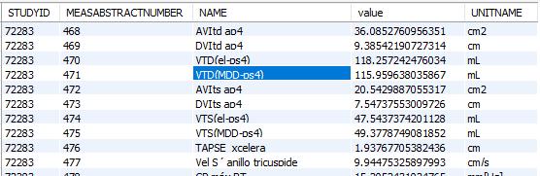

Let us say that we want to know more information about the measurement with name ‘VTD(MDD-ps4)’. We would look at the measabstractnumber, which is 471, in the previous table and do the following query:

select * from echo.A_measgraphref

where studyidk=72283

and MeasAbstractNumber=471;

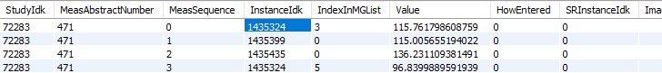

The measurement in the report comes from the average of 4 graphical measurements. Let us locate the SOPInstanceUID of the first measurement:

select * from echo.A_instance

where instanceidk = 1435324;



Now, let us see in which frame it was done:

select * from echo.A_measgraphic

where instanceidk=1435324

and IndexInMGList=3;



It was done on the frame 88. Now, let us see the coordinates of all the points drawn for that graphical measurement:

select * from echo.A_measpoint

where instanceidk=1435324

and IndexInMGList=3;

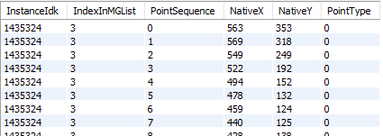

Alternatively, the table A_modvolume will give us very similar information for the volume measurements. This table might be relevant to combine the measurements in the 4 chamber and 2 chambers views:

select * from echo.A_modvolume

where instanceidk=1435324

and IndexInMGList=3;

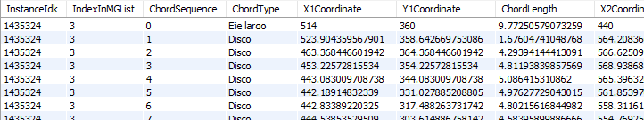

If we want to do a query that gives the SOPInstanceUID of all files with a measurement with name ‘PPVItd’ made on them, we could do a query like:

select a.studyid, a.name, c.SOPInstanceUID

from echo.measurement_abstract_rpt as a,

echo.A_measgraphref as b,

echo.A_instance as c

where a.name like 'PPVItd%'

and a.studyid = b.studyidk

and a.measabstractnumber = b.measabstractnumber

and b.instanceidk=c.instanceidk

limit 5;

